WIFI CONTROLLER USE MANUAL
Catalog
I. Summarize 2
1.01 Data Parameter 2
1.02 Software 3
II. Software User Manual for Android 3
2.01 Installation instructions 3
2.02 WIFI Connection Setting 5
2.03 Software Using Guide 5
(A) Open software： 5
(B) Full-color controller apply interface： 6
(C) Single-color controller apply interface： 7
(D) WiFi color temperature controller interface： 8
(E) RGBW 4 colors controller apply interface： 9
2.04 How Connect Controller to Router 9
III. Software User Manual for IOS 11
3.01 Installation Instructions 11
3.02 WIFI Connection Setting 12
3.03 Software Using Guide 12
3.04 How Connect Controller to Router 12
IV. Answers for Frequently Questions 12
(A) How to solve it when failed to connect to WiFi devicein SINGLE MODE? 12
(B) How to deal with it when password is wrong in SINGLE MODE? 13
(C) How to solve it when failed to connect to WiiFi device in network mode 13
(D) Whose brand or OS of phone can run WiFi device? 14
(E) How many WiFi device can be connected to each phone in SINGLE MODE&NETWORK MODE? 14
(F) Is it possible that multiple phones control one WiFi device? 14

Summarize
    - Name：LED WiFi Controller
    - Model：ZJ-WIFI-310/ ZJ-WIFI-320/ ZJ-WIFI-370
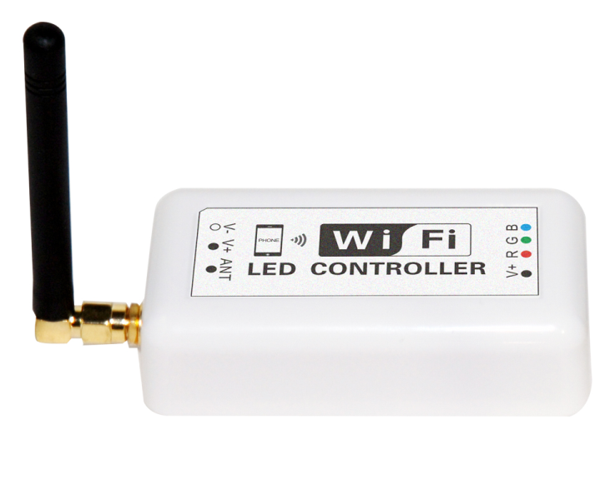
    - Product Summarize：
Welcome to use LED WiFi Controller, this controller is designed for LED strip, module etc. After easy installation and settings, you can use you Phone (IOS or Android system) to control the light. The remote control distance reach 50 meters indoor and more than 100 meters outdoor.
    - Product constitute
NO. | Item | Description
1 | LED WiFi Controller | It is the core of product, responsible for receive control signal and  control LED equipment.
2 | CD | Include mobile soft for IOS operating system and  Android operating system. Product manual.
3 | Wireless router(buy it own) | If you want to use online, suggest to connect wireless router(>150M)

Data Parameter
          - Item version:Single color version,Color temperature version and RGB version
          - Working Voltage: DC7.5-24V
          - Output channel: Can be used 3/2/1 channel
          - Output current: 4A*3 or 4A*2
          - Connecting method: Common anode
          - Dimension: L105.5*W45*H23mm Remote distance: 50 meters indoor, 100 meters outdoor
          - Software: Android system (at least version 2.3 with WIFI function) or IOS system,
          - Language : English/Chinese/German
          - Receiver sensitivity: 802.11b DSSS(-5dBm)，802.11b CCK (-10dBm)，802.11g OFDM(-15dBm)
          - Connect way: V+ R, G, B for LED Light, V+, V- for Power supply, ANT for WIFI signal reception.
          - Reset button(inside the controller): Short press: change from gradual change to strobe flash for single color Version. Or change in 27 modes for RGB Version.
          - Long press(more than 20s): Restore to factory settings. WiFi SSID for connection is “LEDnetXXXXXXXXXX”, password: “88888888”. IP: 192.168.10.1

Software
    - Android Software：
Name | LED Magic Color
Running OS | Android 2.3 or above,request device have WiFi function
Install App | Visit “Google Play”,search “ LED Magic Color”,then download and install it.
Software Size | 1.1M
Language | Chinese/English /Germany, automatic recognize language according to OS.

    - IOS Software：
Name | LED Magic Color
Running OS | IOS5.0 or above,such as iPhone, iPad, and iPod touch device.
Install App | Visit App Store,search”LED Magic Color”, then download and install it
Software Size | 2.1 MB
Language | Chinese/English /Germany, automatic recognize language according to OS.
Category | communication

Software User Manual for Android

Installation instructions
- Download it free by Google Play：
Entre “Google play” app store,search ”LED Magic Color”,find ”LED Magic Color Controller v2”,then download it；
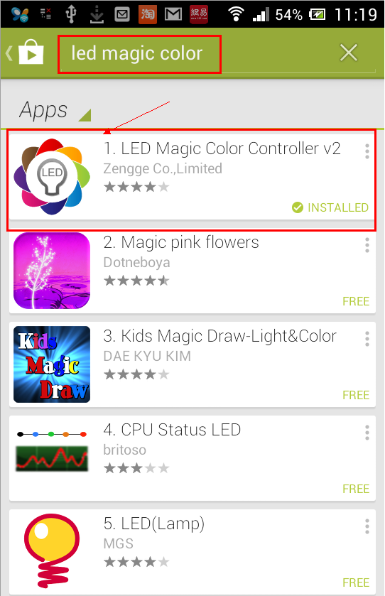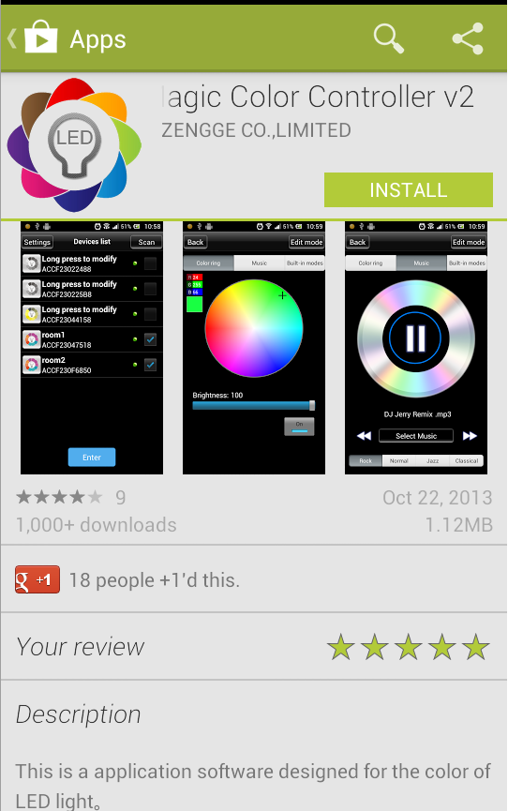
- Install by QR code：
Open QR codesoftware ,then scan following QR code,then download and install it .
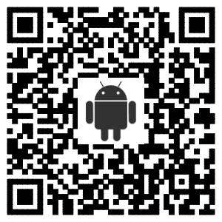
QR code site: http://www.ledmagical.com/Apps/APK/LEDWifiMagicColor.apk
- Install by CD files:
Open CD catalog :Android Software\ LED Magic Color V2.1.0 CN(EN).apk,
You can find “LED Magic Color V2.1.0 CN(EN).apk” installation program 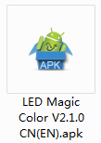 (different phone shows different icon).Pls copy it to phone or connect phone to computer,then click LED Magic Color V2.1.0 CN(EN).apk to install it until finished。

WIFI Connection Setting
Entre to WiFi setting interface,click WLAN”LEDnet*********”,then input password “88888888”.As shown in figures :
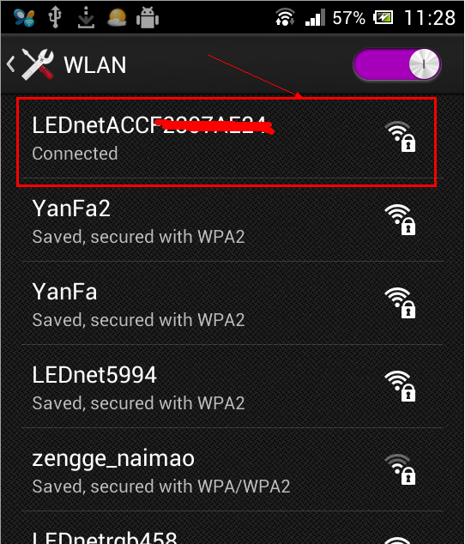 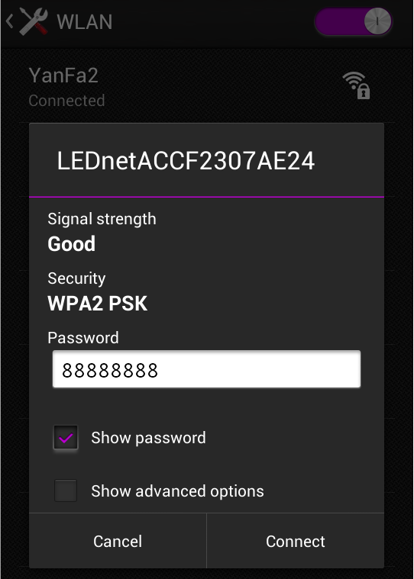

Software Using Guide

Open software：
Click ”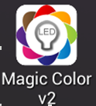” “to open software,then entre to scan interface.If scan successfully,you will find following interface:
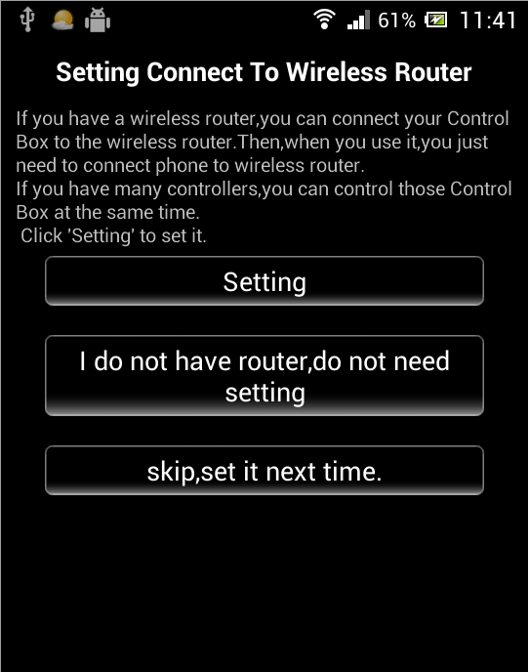  If this is first time you use it,it will shows above interface.It will ask if you want to connect controller to router or not .  You can skip it by click “skip,set it next time”,or click “Setting” to connect controller to router.  About operating instruction,pls refer to chapter”4.04 How Connect Controller to Router” | 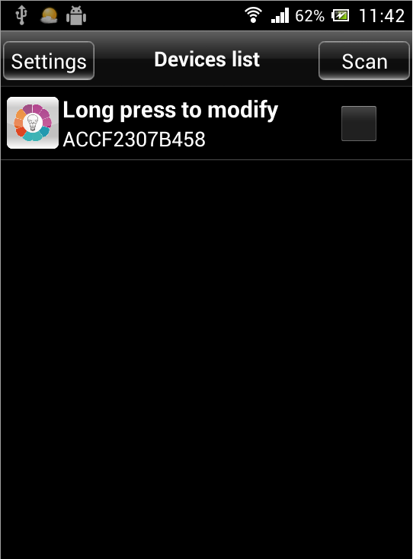  If this is not first time you use it,it will shows above interface.  Notice:if it shows no device when running (the list is empty),it maybe caused by you haven’t connected phone’s WiFi to controller.  Pls refer to “ 4.02 WiFi Connection Setting” to set it .

Full-color controller apply interface：
- Color ring function：
Click any device in controller list,then you can control that device.As shown in figures:
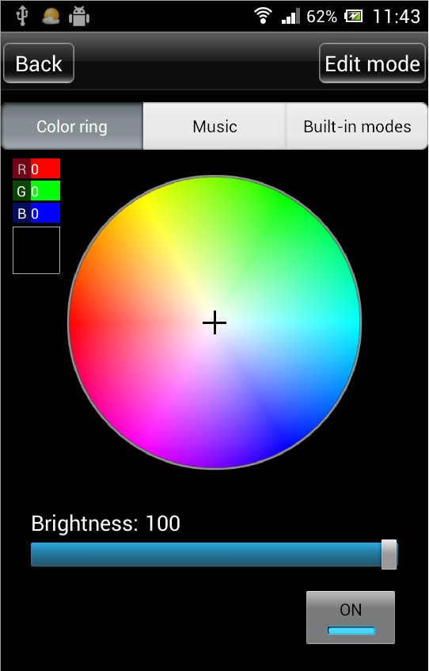
（click color what you want）
- Music control function:
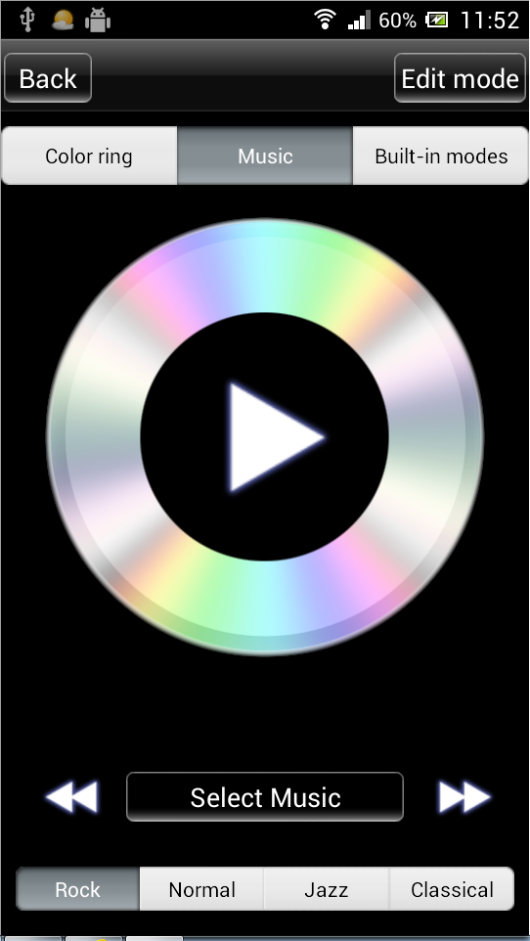 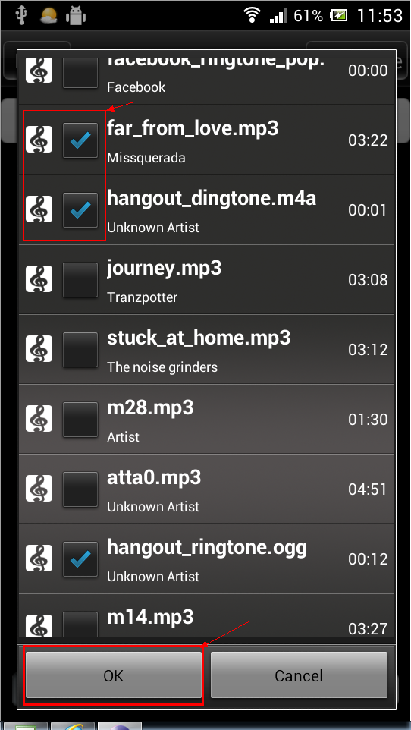 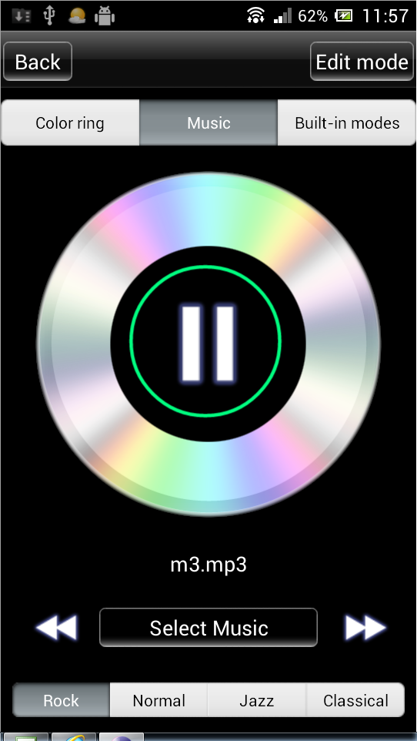
- Built-in dynamic mode function :
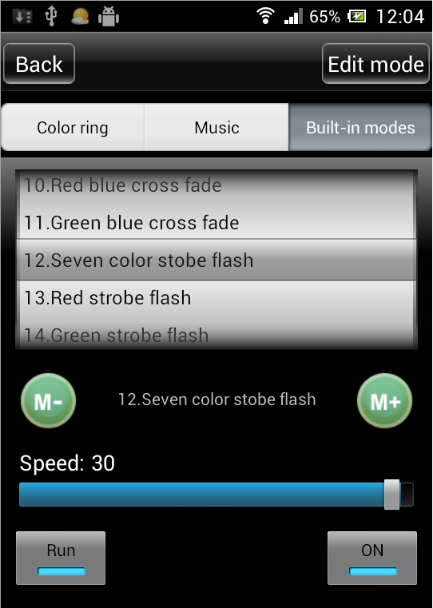 （Notice :scroll it to choose different modes）
- Custom mode function：
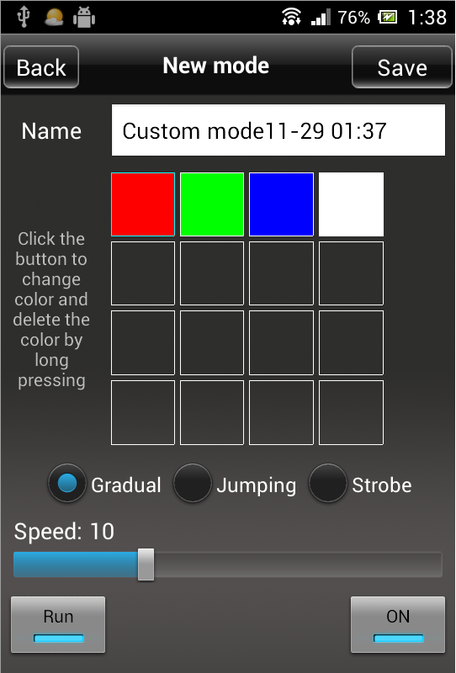 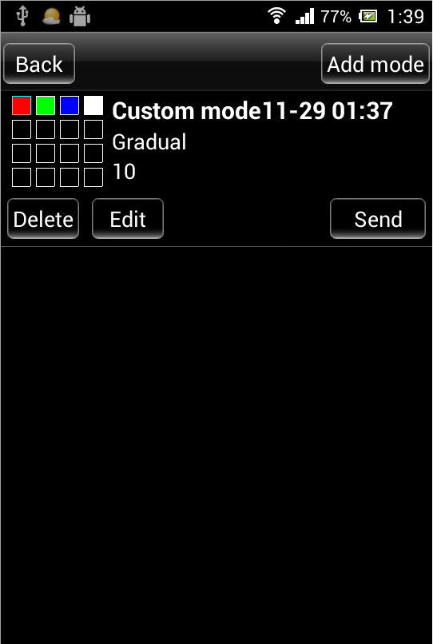

Single-color controller apply interface：
- Single-color control function：
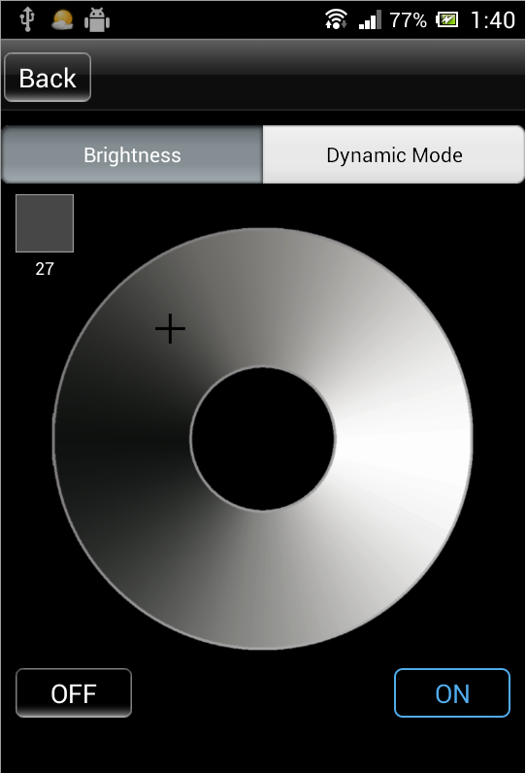
- Dynamic mode control function：
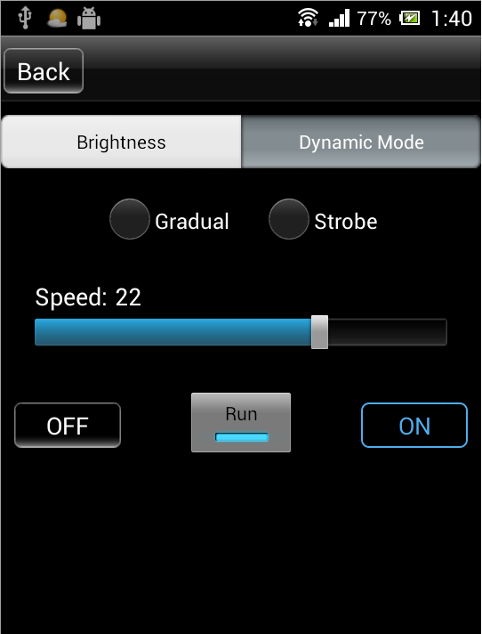

WiFi color temperature controller interface：
- Warm color,cool color control function：
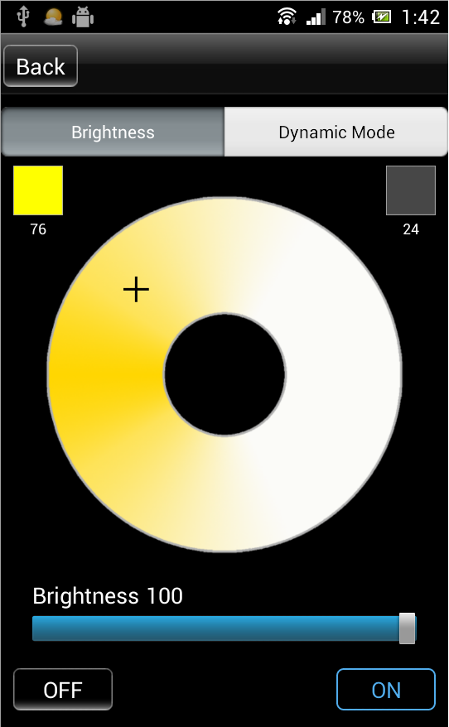
- Dynamic mode function：
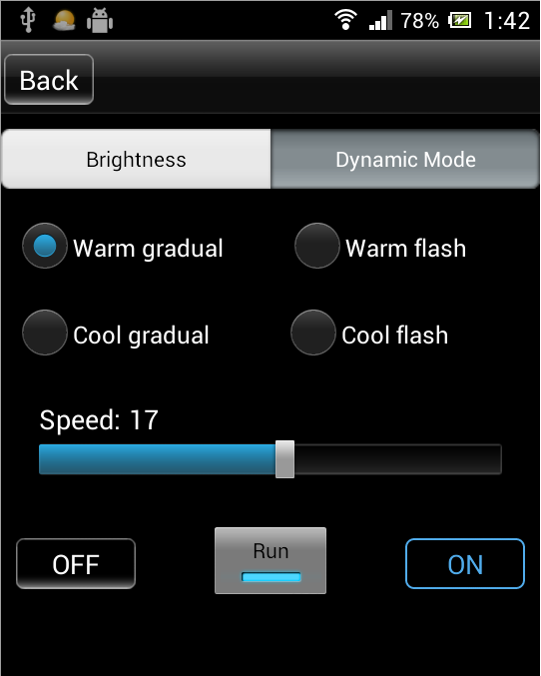

RGBW 4 colors controller apply interface：
- Color ring function：
Choose any color what you like by click it in color ring.
Click “yellow round button” to adjust warm color.
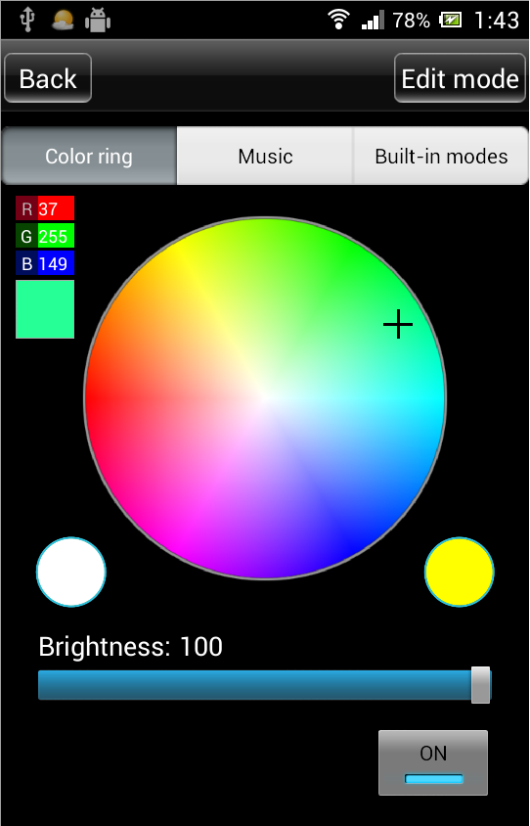
- RGBW 4 colors control function is same as full-color controller.Pls refer to “Full-color Controller Apply Interface”.

How Connect Controller to Router
First Step:Click ”Settings” to entre to setting interface.  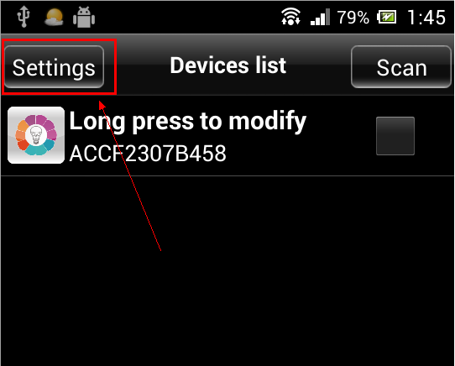 | Second Step:Choose right device.  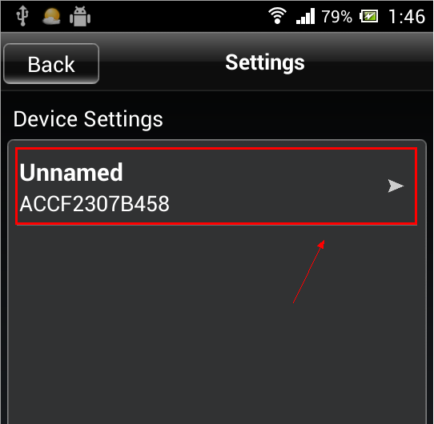
Third step:Choose “Link to Wireless Router” in network mode.  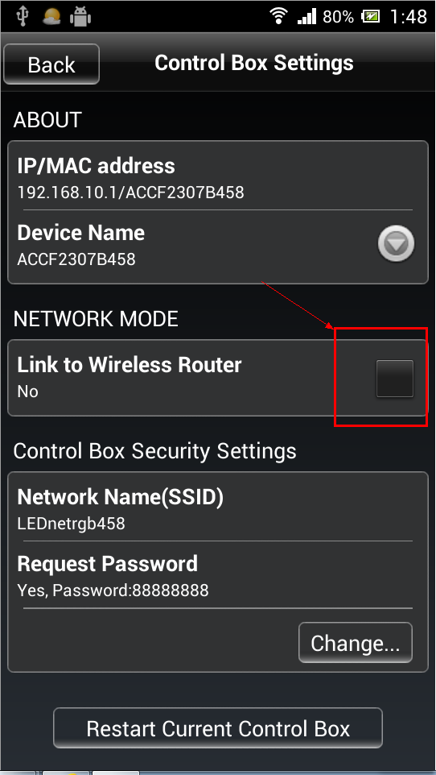 | Fourth step:Click right router ,then input router’s password.  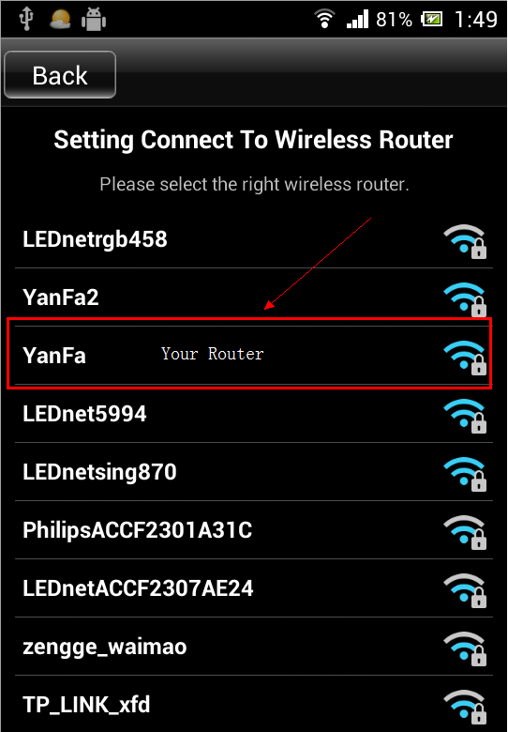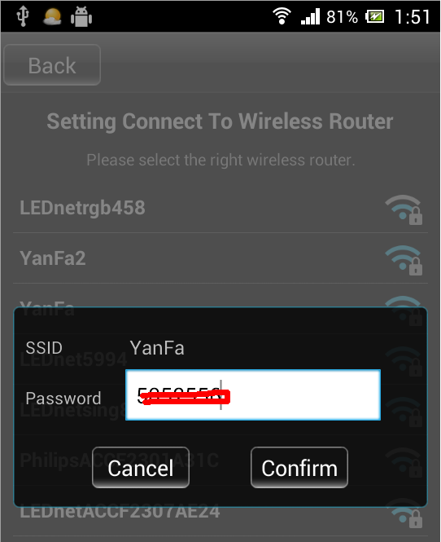
Fifth step:Waiting “The Control Box is restarting ,pls wait …”.  If above operating was successful,it will shows that interface “The Control Box is restarting ,pls wait …” ,you just need to wait dozen seconds .  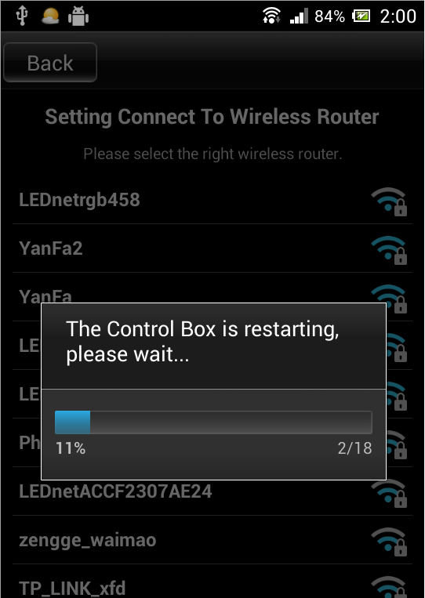 | Sixth step:Connect phone to router Entre to phone setting interface,then entre to WLAN interface,reconnect your router.Finally,restart app after connected successfully!  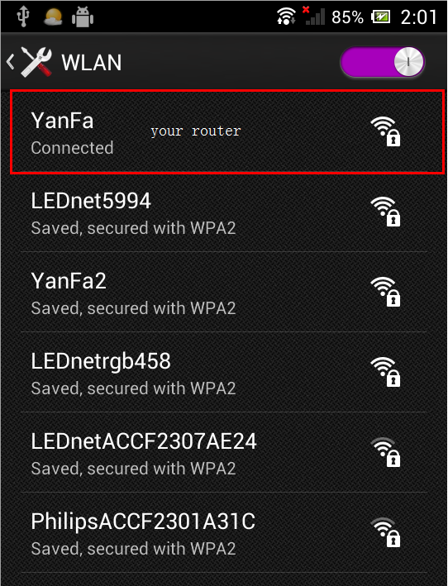
Seventh step:Network mode  If you have a lot of controllers,pls redo above work.Connect all controllers to wireless router,then connect phone ‘s WiFi signal to router.Finally,you can find all controller in app after restarting.  Choose device what you want,then click “Entre” to control multiple devices. | 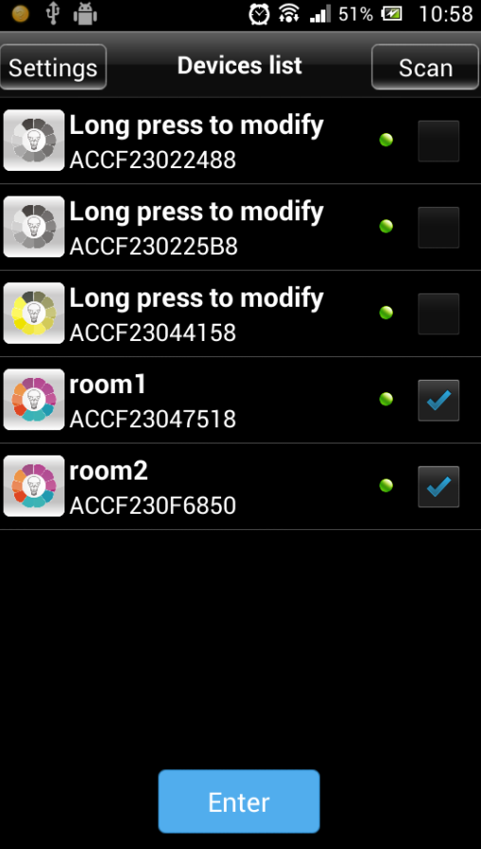

Software User Manual for IOS

Installation Instructions
- Download it free by “App Store”：
Entre to “App Store”,search ”LED Magic Color”,find ”LED Magic Color Controller v2”,then download and install it.
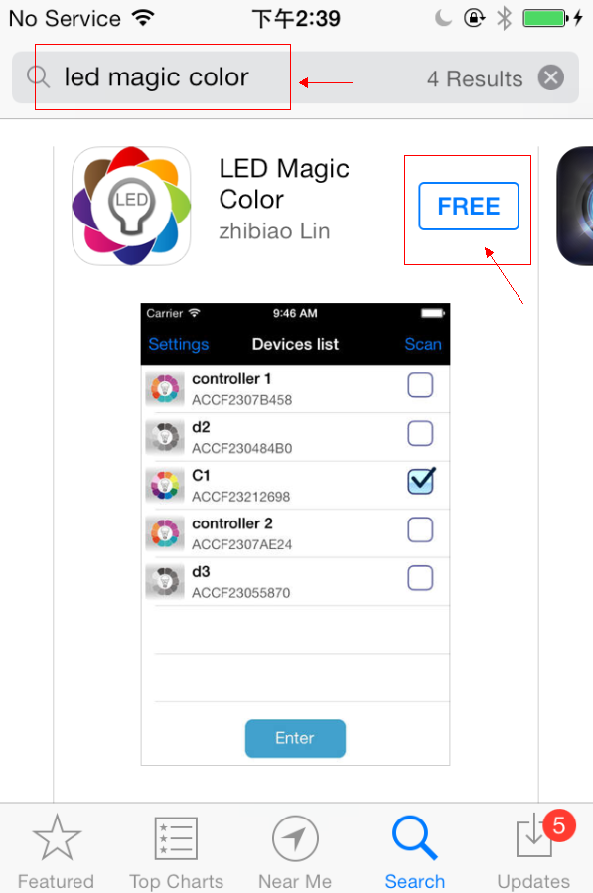
- Install by BQR code and website：
Open BRQ code app ,then scan following BRQ code.Phone will auto shows a site,then download and install it.
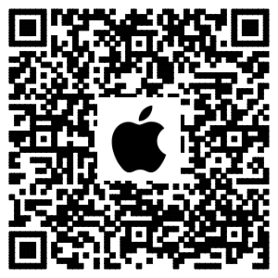
Click following site,phone will auto jumps to “App Store”:
Site: https://itunes.apple.com/us/app/led-magic-color/id595148649?ls=1&mt=8
- Install by CD files(just suitable for phone which can access any Web site)：
Open CD catalog :IOS Software \ LED Magic Color V1.3 CN(EN).ipa,
You can find installation program:LED Magic Color V1.3 CN(EN).ipa,then copy it to phone or connect phone to computer.Click”LED Magic Color V1.3 CN(EN).ipa” to install it.

WIFI Connection Setting
Entre to WiFi setting interface,click WLAN”LEDnet*********”,then input WiFi password: ”88888888”.As shown in figures:
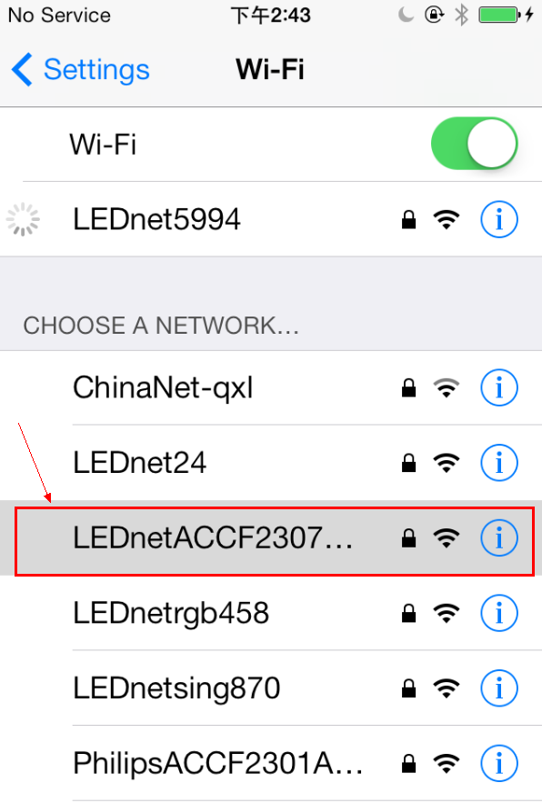 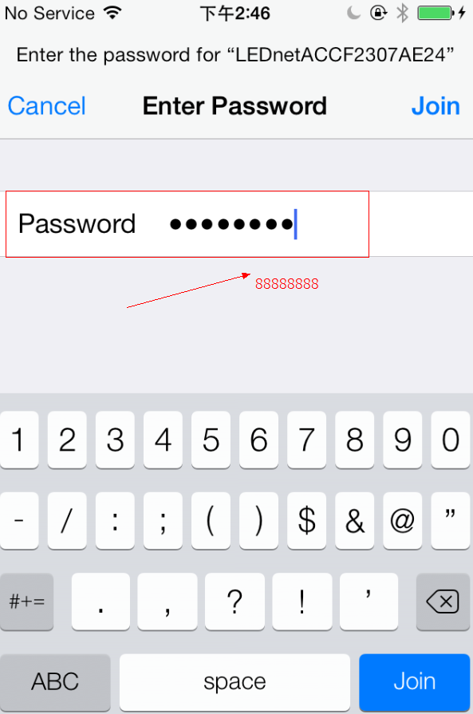

Software Using Guide
Pls refer to software using guide for Android.

How Connect Controller to Router
Pls refer to Android guide chapter “3.04 How Connect Controller to Router”

Answers for Frequently Questions

How to solve it when failed to connect to WiFi devicein SINGLE MODE?
Answers:
If you want to control it successfully in single mode,you must satisfy following three conditions:
1）、Antenna of controller and power supply were connected correctly .
2）、Phone can be connected to WiFi network normally.
3）、Set controller to single mode.
Pls check your phone as following steps:
1）、Check if controller’s antenna works well and controller are power on or off.
2）、Check if controller were connected to WiFi succefully.If not,pls open WiFi setting interface,search controller’s WiFi signal and connect it.Default WiFi name of controller is ”LEDnetxxxxxxxxxxxx”,password is ”88888888”.
3）Check if your app is the newest.Click “Settings”,entre to setting interface,then you can check your app version.As shown in figures:
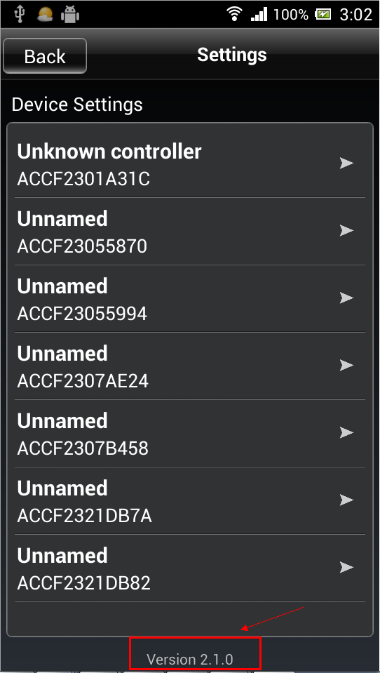 (Android OS) 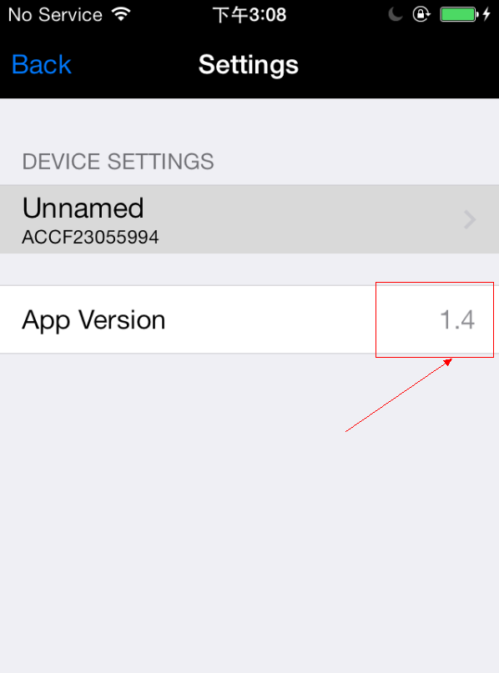（IOS）

How to deal with it when password is wrong in SINGLE MODE?
Answers:
If you forget your previous password,pls power on your controller,then long press “Reset” for 10s and wait additional 10s.Restart controller,then controller was reset to “factory reset”.Default password in single mode is:88888888

How to solve it when failed to connect to WiiFi device in network mode
Answers:
If you want to control it successfully,you must satisfy following conditions:
1）、Antenna of controller and power supply were connected correctly
2）、Phone can be connected to WiFi network normally.
3）、Check if controller were connected to WiFi succefully.Following three steps show you how to check the connection status in single mode.
3.1 Connect the phone’s WiFi signal “LEDnetxxxxxxxxxx”to controller.:
3.2 Run app and make sure it shows your LED device.
3.3 Entre to setting interface,and check device’s setting info,then check status of network.If status is “Connected”,it means network works well.As shown in figures.
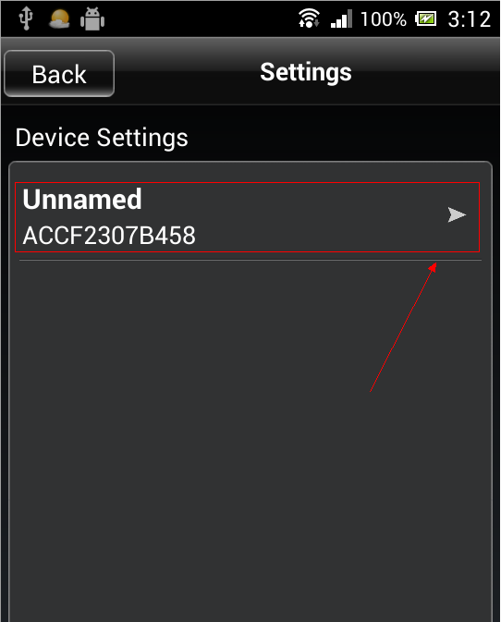 -----------> 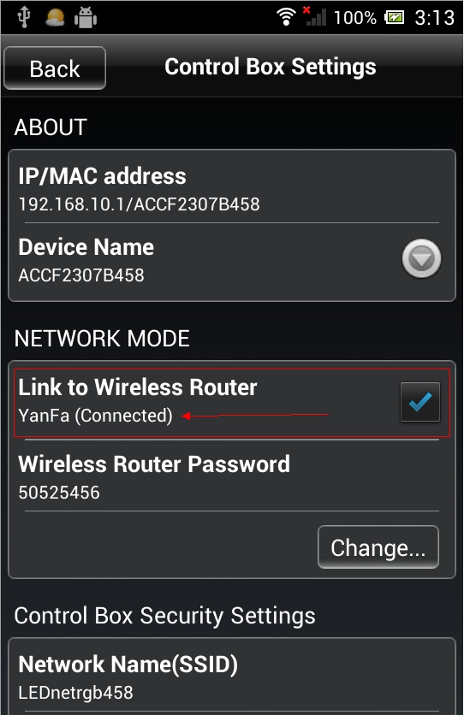
If status is “Unconnected”,pls check password is right or not.If password is wrong ,pls click “Change…” to reconnect it to controller.
4）、 If password is right,but status is still shows “Unconnected”,pls power off controller first and restart it after 3s.Then wait additional 3minutes.Finally,check controller’s network status by same methods.
5）、If all problems still not be solved after checking by above methods,pls restart your router and controller.
6）、 If all problem still exists,pls try to use new router.

Whose brand or OS of phone can run WiFi device?
Answers:
For Android OS,support Android 2.3 or above;For IOS,support IOS5.0 or above.

How many WiFi device can be connected to each phone in SINGLE MODE&NETWORK MODE?
Answers:
In single mode,each phone can connect 1pcs WiFi device at once time.
In network mode,qty that how many WiFi device can be connected depends on router level,no business of WiFi device.

Is it possible that multiple phones control one WiFi device?
Answers:
For controller:Yes,it is possible..
For WiFi bulb:Support 2 phones in single mode.Support 2 phones in network mode.

